Top of Form
Bottom of Form
Top of Form

‎
FINANCIAL EXPRESS

April 28 2016
Bottom of Form

Unshackling the power sector by S L Rao

The Centre must focus on overall policy, and play a strong technical advisory and a coordinating role. It must not interfere in management decisions of an enterprise
By: SL Rao | Published: April 28, 2016 5:30 AM
0 0 G+0 0

a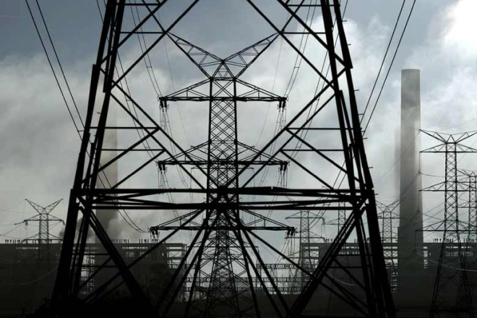
A single market for electricity over all of India has commenced.(Photo: Reuters)
Governance of electricity (power) in India is a concurrent subject in the Constitution. The Centre controls all fuels (coal, oil & gas, nuclear). In electricity, it controls all central-government-owned undertakings, enterprises that supply more than one state, interstate transmission and trading. State governments have exclusive authority over all issues relating to power within the state. Power flows over long distances and over more than one state. But within a state, tariffs, safety, new projects and governance of undertakings are all with the local government.
A single market for electricity over all of India has commenced. Many states buy directly from generating companies in other states. An electricity exchange enables daily trading to balance supply with demand. Interstate transmission lines are being added to make single market a reality. The Electricity Act allows open access, i.e. access to suppliers and customers everywhere. This is subject to state government permission. Many times, this is not given in order to use expensive, locally-generated power. Sales within many states are, on an average, below cost. State-owned distribution companies are largely loss-makers. Even privately-owned or managed companies are allowed tariffs that do not give an adequate return on investment.
Governments exercise control through policy pronouncements, second-guessing enterprises on all major enterprise decisions (top appointments, investment, power purchase, etc). Appointments to run government-owned electricity undertakings, as well as of statutory regulators, are made by the concerned governments, mostly from among retired public servants. There is little professional management in electricity enterprises, especially in distribution and in state-government-owned undertakings. Professionals are not encouraged to seek careers in electricity undertakings. Authority is centralised and there is little delegation. There is also less accountability for results.
Within each state and nationally, balancing electricity supplies with demand every minute is vital, and is done by state load dispatch centres (SLDC). This function must be a neutral one between generators, distribution enterprises and users. It is not, but controlled by the concerned government. At central and state levels, top departmental officials give directions from the ministry on crucial issues of investment, maintenance, modernisation, etc.
Such government departments are, many a times, second-guessing managements. It has been established that this damages the autonomy of decision-making in autonomous enterprises, and confuses matters through cross-subsidies, centralised operations, etc.
So, how can the power system be made more transparent and efficient?
Appointing of professionals who are capable of independent decision-making;
Denying an oversight authority over autonomous enterprises to government departments;
Subjecting enterprises to rigorous independent audits of operations and finances;
Enforcing individual accountability at all levels in the enterprise, with detailed job descriptions, objectives and timely evaluations done regularly;
Levying penalties and rewards.
Over time, electricity enterprises must move from being wholly owned by the government to being wholly owned but with a clear lakshmana rekha drawn between government and management. Electricity enterprises could be registered companies, cooperatives or a departmental enterprise. As corporate enterprises, these power utilities become subject to the company law and its consequences for malfeasance. Shareholders can examine managements on performance. Autonomy can be better ensured. But in all cases, regulators must be truly independent, not surrogate for governments.
Unlike now, the Board of Directors must be fully and finally responsible for performance of the enterprise. So long as there is government ownership, there should be a public utilities commission (for central and state levels) that searches for and appoints suitable people to such Boards, and also their CEOs. Departments of the government should play no role in this effort. The owner (government or private) should not exercise any management control. The Board of Directors must be supreme in relation to management.
Dr Joel Ruet describes pathetic management practices in SEBs with government officers in overall control. Even in the joint sector discoms in Delhi, the government representatives on Boards show little interest or understanding of the enterprise.
The role of government electricity departments at both the Centre and states is confusing and conflicting. The Centre must play an overall policy role, a strong technical advisory role, and a coordinating role. But it must not interfere in management decisions of an enterprise. There could be a National Electricity Commission (with all states in it) that meets regularly and resolves issues. The CEA should be its technical advisor. At the state level, the statutory regulator should be the overseer of the sector. The SLDC should be an autonomous body owned by all users.
There must also be a public utilities commission on the lines of the UPSC to select and nominate Board members, CEOs and oversee Board functioning. This should apply to all cases where the government has over 25% equity. Shareholders should demand accountability through financial parameters. All departmental enterprises must be corporatised with independent Boards appointed as above.
The quasi-monopoly of PGCIL (PowerGrid) in interstate transmission has put limits on electricity trading. Government departments should facilitate speedy approvals for new lines, and the tribunal or regulators must be approached if PGCIL stands in the way of competitive entries. The CEA must make the national transmission plan and it should be approved by the Central Power Commission.
Even if state government departments of power are not abolished, they must be rigidly distanced from power enterprises, their governance and management. Also, internal management structuring of electricity enterprises must be professionally studied and reorganised to provide decentralisation, delegation and accountability.
Demand and supply forecasting, reliability, advance preparation for shortfalls and surpluses at the enterprise level, must be made by each enterprise and coordinated by the CEA. At state, regional and national levels, it must be agreed at with the National Power Commission. In addition, a power market research body must regularly report on efficiencies, thefts, “free” power, etc, and ensure data quality.
The Electricity Act should be amended and we have to abolish cross-subsidies which cause considerable accounting and financial problems to discoms. Similarly, strict accounting rules must be laid down for subsidy accounting, claims and reimbursements by governments.
The author is former director general, NCAER, and was the first chairman of the CERC
0 0 G+0 0

Bottom of Form
a

